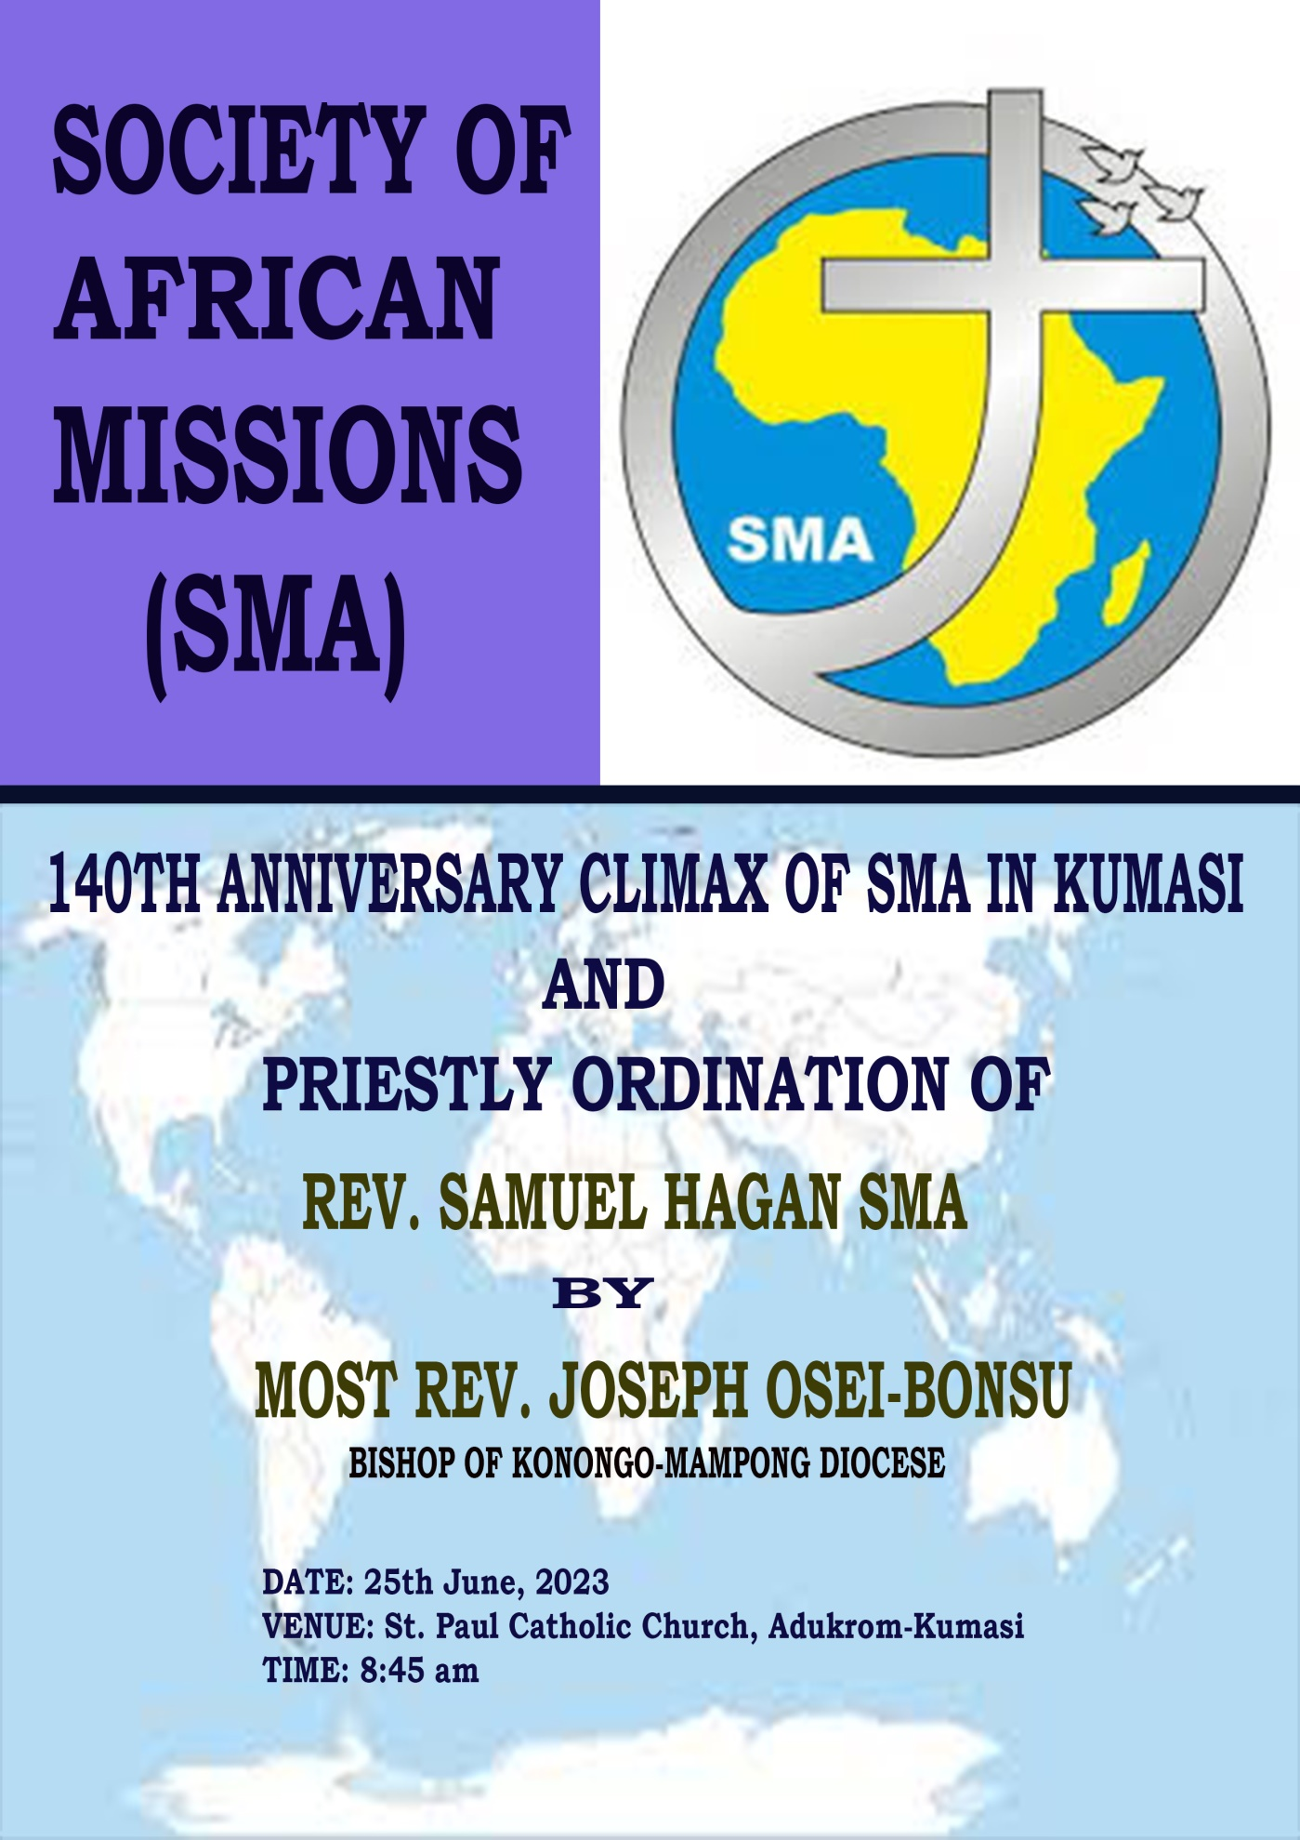

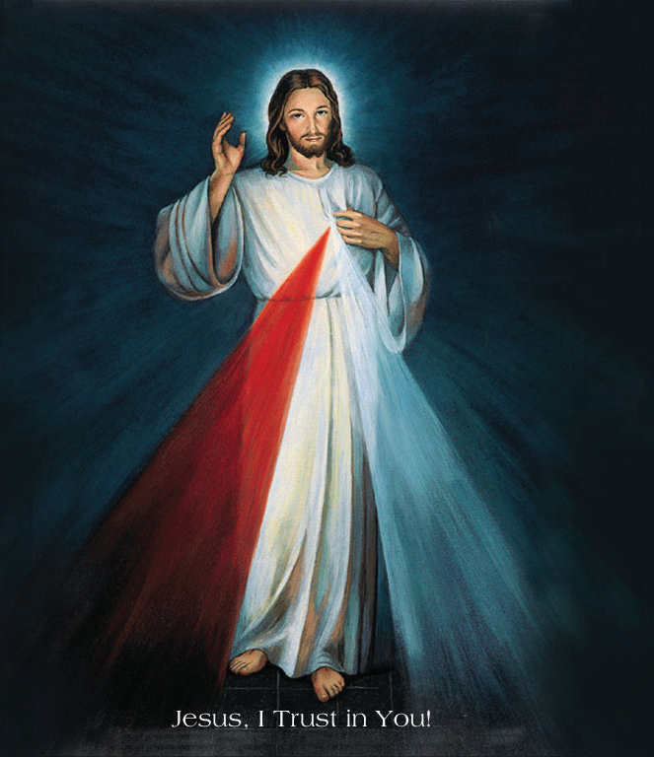

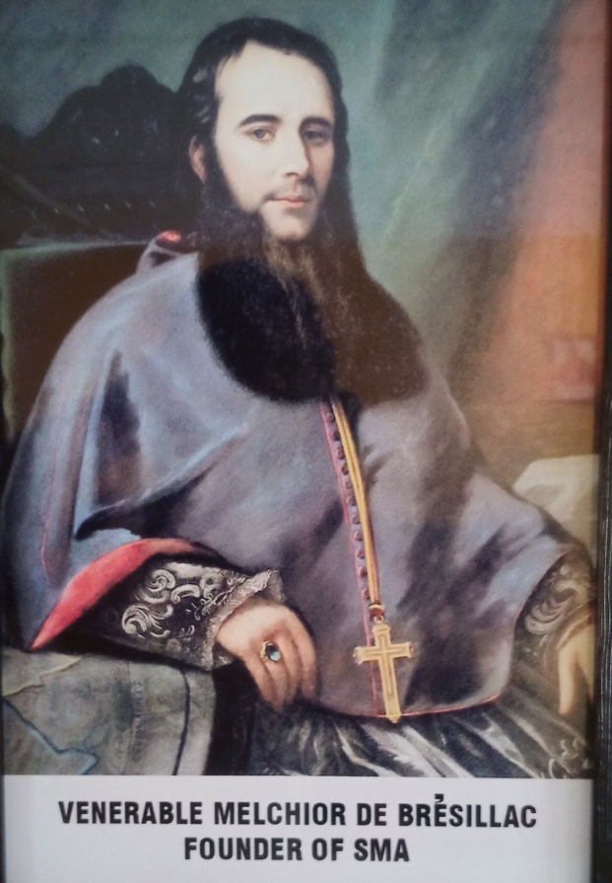

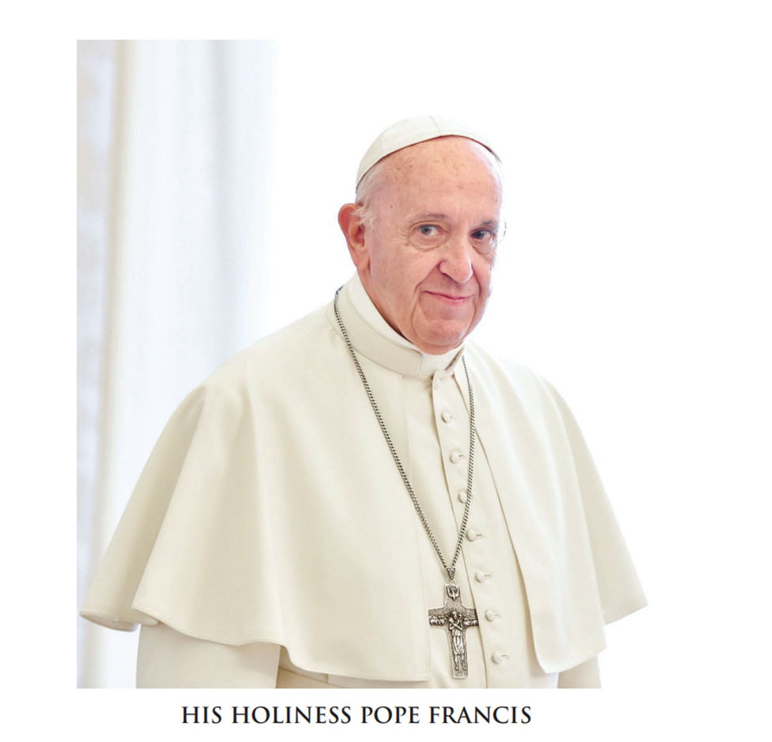

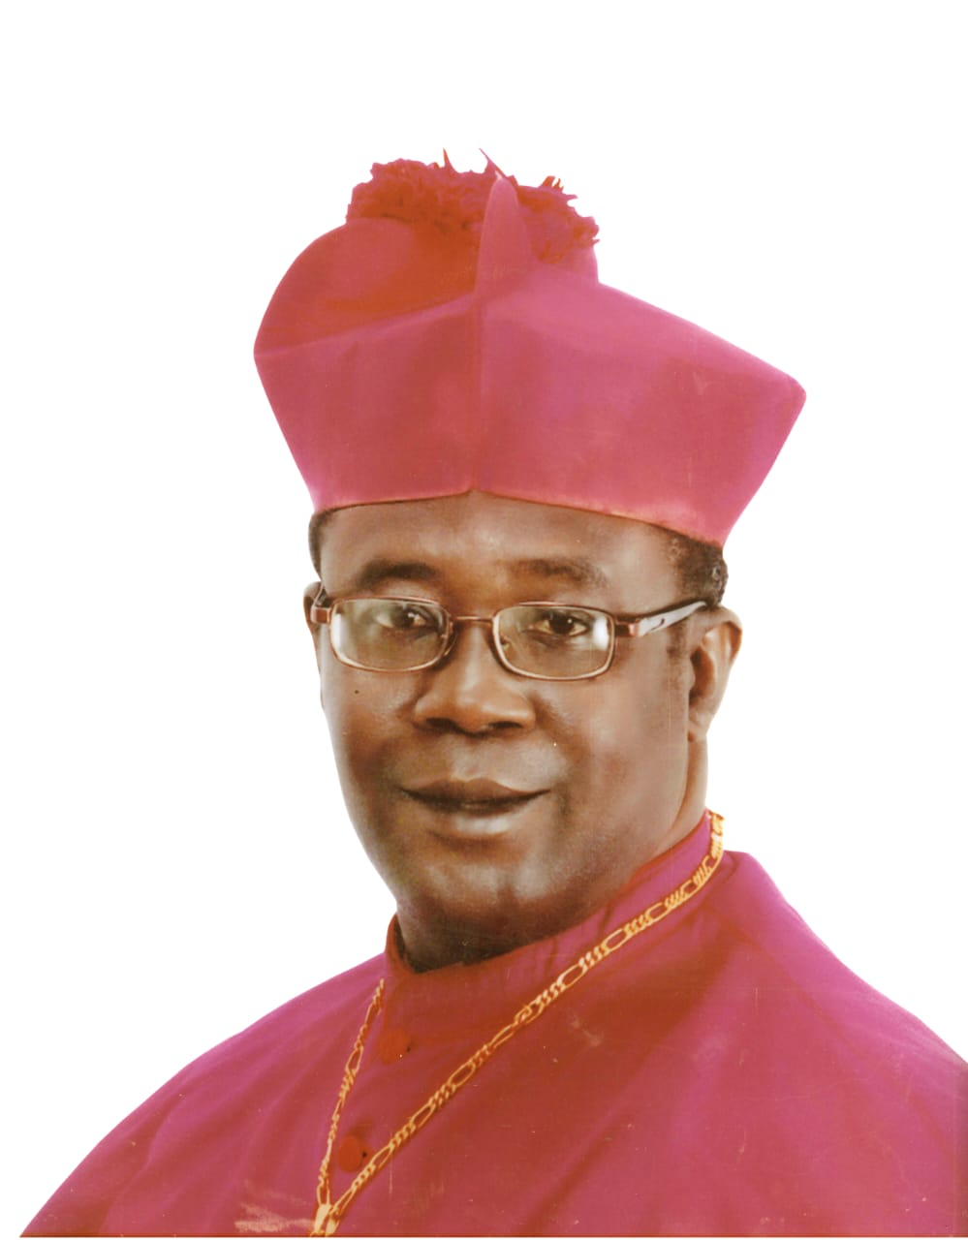

MOST REV. GABRIEL JUSTICE YAW ANOKE

(METROPOLITAN ARCHBISHOP OF KUMASI)

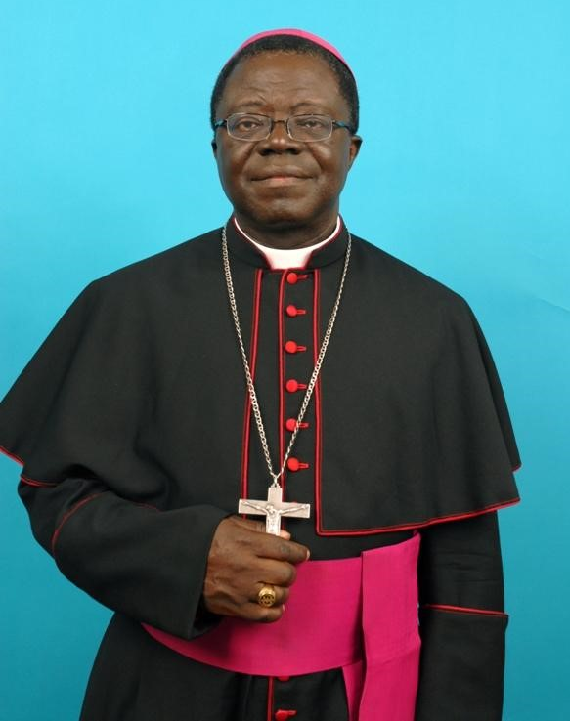

MOST REV. JOSEPH OSEI-BONSU

(BISHOP OF KONONGO-MAMPONG)

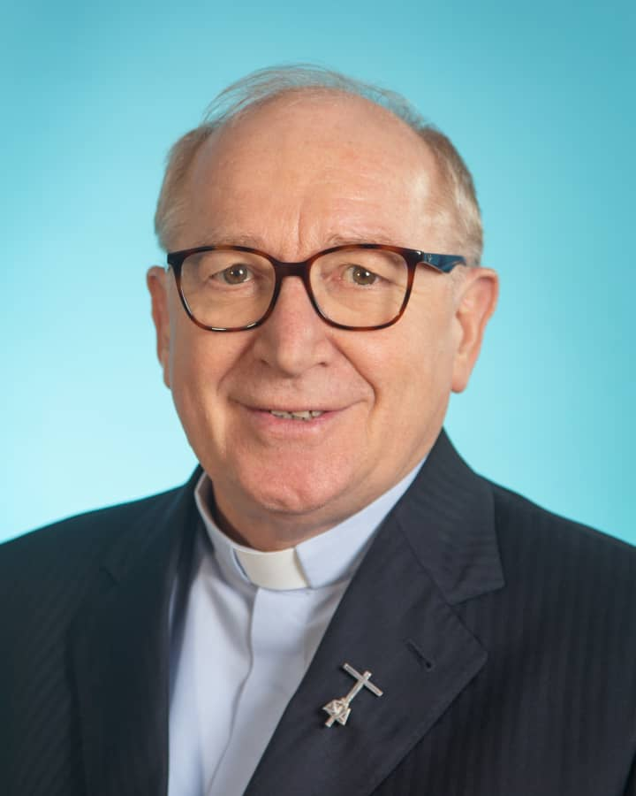

VERY REV. ANTONIO PORCELLATO, SMA

SUPERIOR GENERAL

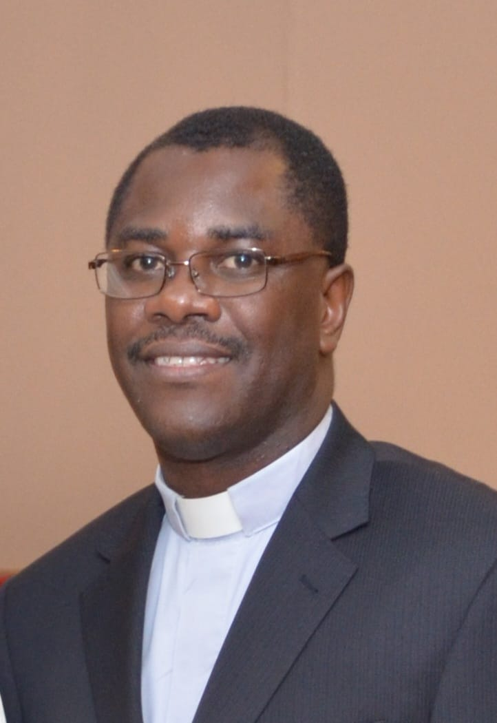

VERY REV. FR. DR. PAUL ENNIN SMA

PROVINCIAL- GHANA PROVINCE

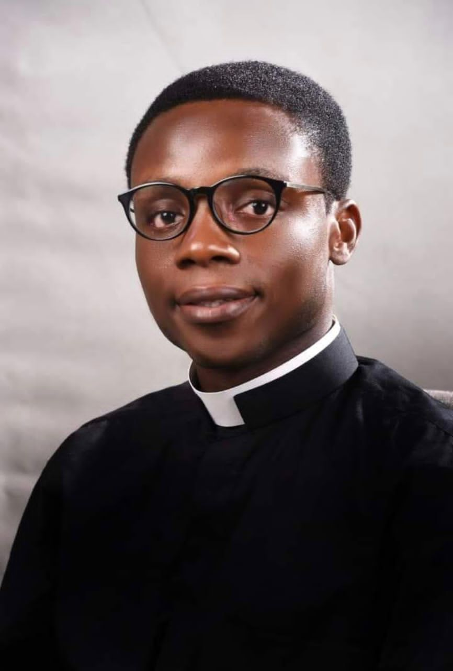

**REV. FR. AMOS QUANSAH, SMA**

(PARISH PRIEST, ST.PAUL’S PARISH, ADUKROM)

FUNCTIONARIES

MAIN CELEBRANT

* **Most Rev. Joseph Osei-Bonsu.**

THRONE PRIESTS

* Very Rev. Fr. Dennis Senyo Etti, SMA
* Rev. Fr. Amos Quansah, SMA

DEACONS

* Rev. Benjamin Bondzie, SMA
* Rev. Theophilus Ntri-Andoh
* Rev. Gregory Asomaning-Agyeman

CALLING OF CANDIDATE

* Rev. Fr. Paschal Deo-Angyi, SMA

**PRESENTATION OF CANDIDATE**

* Very Rev. Fr. Dennis Senyo Etti, SMA – Vice-Provincial Superior

CHOIR IN ATTENDANCE

* St. Paul Mass Choir

LECTORS

* 1st Reading – Rosemary Boateng
* 2nd Reading – Patrick Biney, sma

**MC**: Rev. Fr. Auracio B. Tegbui, SMA

ORGANIST: Felix Ampadu Tawiah

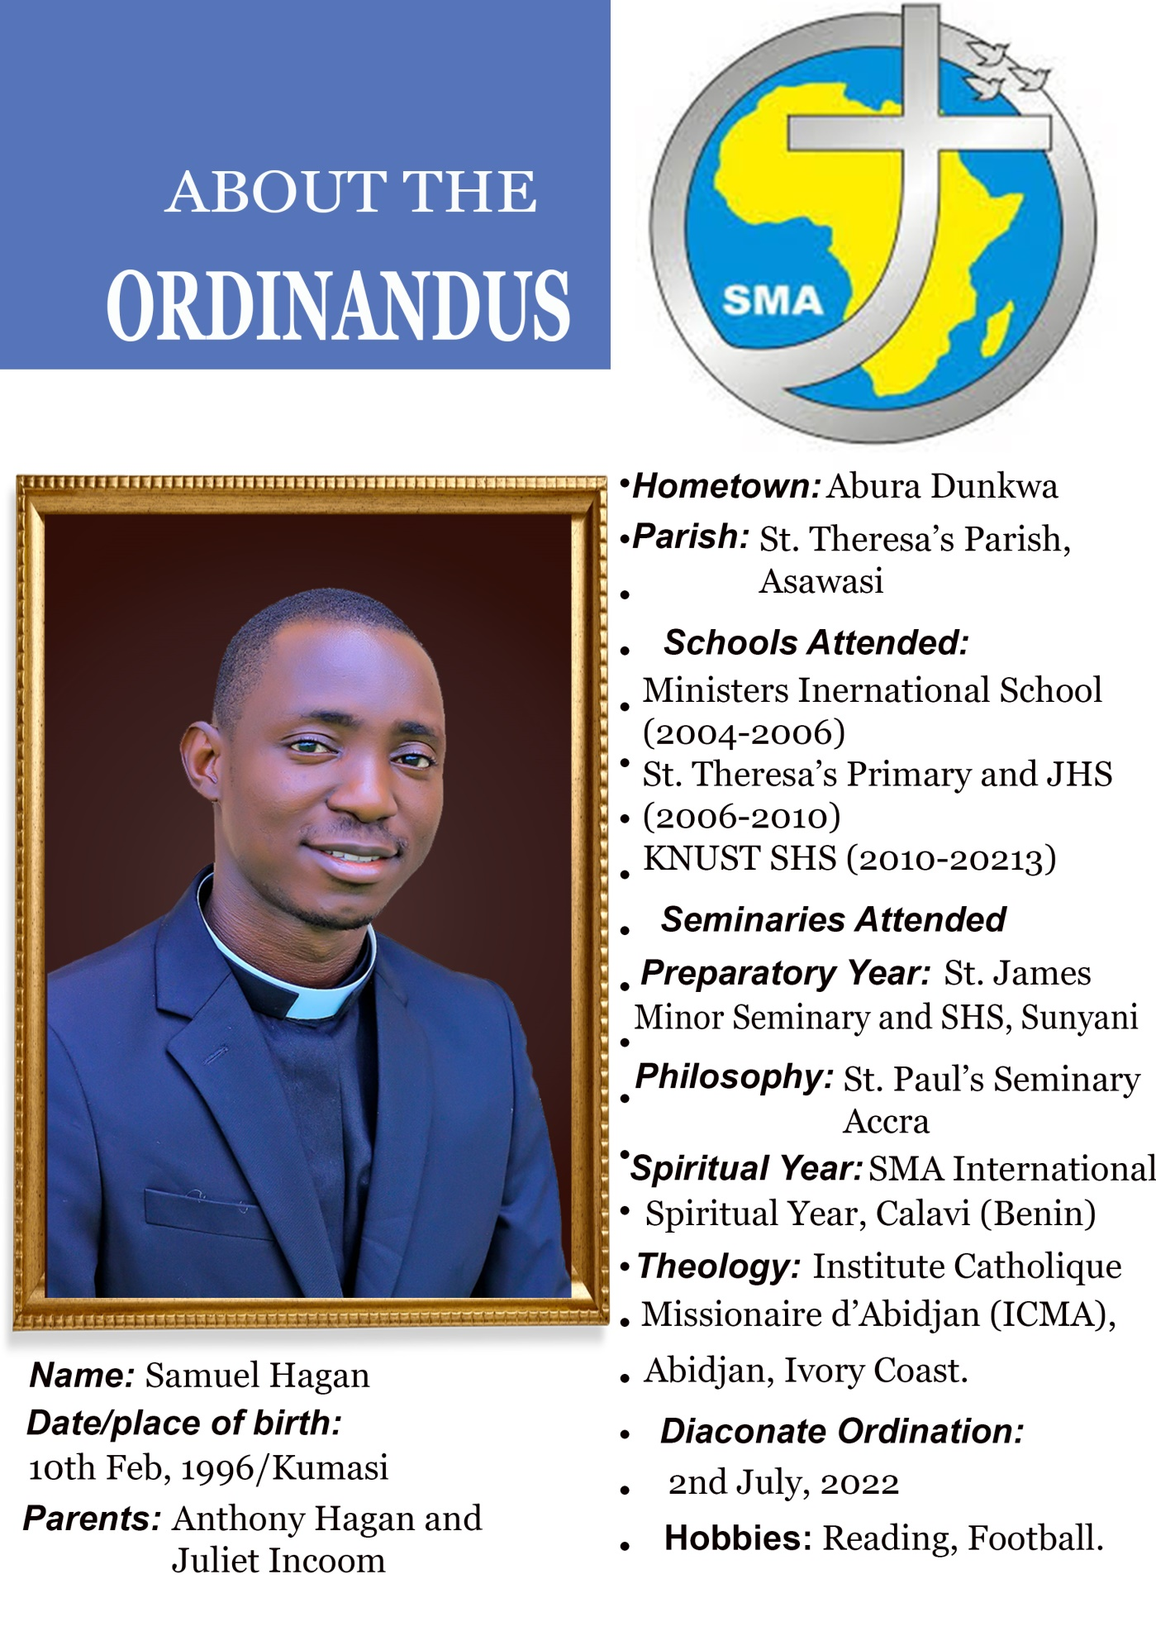

# ORDER OF MASS

8: 45: AM : PROCESSION BEGINS

ENTRANCE : Priestly People – CH 420

INTROIT : Ecce Sacerdos Magnus

INCENSATION : Ewurade ne fie

Welcome address by the Parish Priest of St Paul

KYRIE

GLORIA

LITURGY OF THE WORD

First Reading : Jeremiah 1 : 4 - 9

Responsorial Psalm : Psalm 109 : 1 -4

Response : You are a priest forever, a priest like Melchzedek of old

Second Reading : 1Cor. 9 : 16 - 27

Gospel Acclamation : The Lord is my shepherd there is nothing I shall want. Goodness and mercy shall follow me all the days of my life.

Enthronement of the Holy Bible:

Gospel : Matthew 28 : 16 - 20

ORDINATION RITES

Commentary

Song : Here I am, Lord

CALLING OF CANDIDATE

Priest: Let he to be ordained Priest, please come forward:

(The candidate is called by name)

**Candidate:**  Here I am, Lord

(And goes to the Bishop, with his parents before whom he makes a sign of reverence)

PRESENTATION OF CANDIDATE

Priest: Most Rev. Father, Holy Mother Church asks you to ordain this man, our brother for

service as Priest.

**Bishop**: Do you judge him to be worthy?

**Priest**: After inquiry among the people of Christ and upon recommendations of those

concerned with his formation, I testify that he has been found worthy.

**ELECTION BY THE BISHOP AND CONSENT OF THE PEOPLE**

B**ishop says**: We rely on the help of the Lord God and our Savior Jesus Christ and

we choose this man, our brother, for priesthood in the presbyteral order.

**All present:** Thanks be to God

HOMILY

Commentary

EXAMINATION OF CANDIDATE

**Bishop**: My son, before you proceed to the order of the presbyterate, declare before the people your intention to undertake this priestly ofﬁce.

Are you resolved, with the help of the Holy Spirit, to discharge without fail the ofﬁce of priesthood in the

presbyteral order as a conscientious fellow worker with the Bishops in caring for the Lord’s ﬂock?

**Candidate**: I am

**Bishop**: Are you resolved to celebrate the mysteries of Christ faithfully and Religiously as the Church has handed them down to us for the glory of God and the sanctiﬁcation of Christ’s people?

**Candidate:** I am

**Bishop**: Are you resolved to exercise the ministry of the word worthily and wisely, preaching the Gospel and explaining the Catholic faith?

**Candidate**: I am

**Bishop**: Are you resolved to consecrate your life to God for the salvation of His people, and to unite yourself more closely every day to Christ the High Priest, who offered himself for us to the Father as a Perfect Sacrifice?

**Candidate**: I am, with the help of God

**PROMISE OF OBEDIENCE**

**Bishop:** Do you promise Respect and Obedience to your legitimate Superior and his Successors?

**Candidate**: I do

**Bishop**: May God who has begun the good work in you bring it to fulfillment.

**Candidate:**  Amen

**Commentary**

**INVITATION TO PRAYER**

Then all stand, and the Bishop, without his miter, invites the people to pray:

**Bishop:** My dear people let us pray, that the all-powerful Father may pour out the

gifts of heaven on this servant of his, whom He has chosen to be Priest.

**Commentator**: Let us kneel (All kneel but the candidate prostrates)

**LITANY OF SAINTS**

**(*SMA PATRIMONY*)**

Eternal Holy Father, Adorable Father,

Eternal Source from which comes all graces,

The Church rejoices, sings your marvels,

And we pray to you. . …………………….**O Lord have mercy (2x).**

Eternal Word, Jesus Christ,

Light from Light, True Son of God,

The Church rejoices, sings your marvels,

And we pray to you……… …………….**O Christ have mercy (2x).**

Holy Spirit, Father of the Poor, Lord who gives life,

Invincible force and fire at the heart of the world,

The Church rejoices, sings your marvels

And we pray to you………… ………….**O Lord have mercy (2x).**

Holy Mary, Immaculate Virgin, Mother of God………………………Pray for us.

Daughter and Servant of the Almighty, Spouse of the Spirit………………..Pray for us.

Queen of Angels and Virgin who became the Church… Come and be with us, Pray for us.

St. Joseph, Spouse of the Virgin Mary………………………………...Pray for us.

Faithful Servant to whom God entrusted his only Begotten Son……...Pray for us.

Just man who looks after the Church of Christ………….Come and be with us, Pray for us.

St. Peter and St. Paul, St. John, St. James and all the Apostles of Christ…………Pray for us.

St. Mark, St. Luke and all the Evangelists…………………………..……...……..Pray for us.

You who have announced the Risen Lord……………….Come and be with us, Pray for us.

St. Mary Magdalene………………………………………………..…Pray for us.

And you Mary, Martha and Lazarus, St. Veronica…………………...Pray for us.

Holy women who run to the tomb in the morning of the resurrect-

tion……………….………………………….Come and be with us, Pray for us.

St. Ignatius of Antioch, St. Lawrence…………………………………..….Pray for us.

St. Perpetua and St. Felicity, St. Agnes…………………………………….Pray for us.

St. Agatha, St. Cecilia and all the Holy Martyrs………Come and be with us, Pray for us.

St. Augustine, St Gerard and St John Paul II………………………………Pray for us.

St. Basil, St. Benedict, St. Bernard and St. Dominic……………..Pray for us.

St. Ignatius of Loyola, St. John of the Cross, St. John Mary Vianney…………………………………………………Come and be with us, Pray for us.

St. Francis Xavier……………………………………….……………………...Pray for us.

St. Theresa of Lisieux, St. Peter Claver………………….…………………….Pray for us.

You, Saints Patron and models of mission of yesterday, today and forever……………………………………………….....Come and be with us, Pray for us.

St. Francis of Assisi, St. Anthony of Padua……………………...Pray for us.

St. Clare, living prayer of the Church…………………………....Pray for us.

St. Bernadette and all the minor Friars………………….Come and be with us, Pray for us.

St. Charles Lwanga, St. Kaggwa, St. Mukasa………….………..Pray for us.

St. Kizito, St. Mulumba, St. Serunkuma………………………...Pray for us.

All the Holy Martyrs of Uganda……………………….Come and be with us, Pray for us.

St. Josephine Bakhita, Blessed Anuarite…………………….…..Pray for us.

Blessed Bakanja, Blessed Michael Iwene Tansi………………...Pray for us.

All unknown Saints who fecund the Church of Africa….Come and be with us, Pray for us.

All You, Saints of God…………………………………………….Pray for us.

You who with the help of God, served him faithfully……….…..Pray for us.

You who contemplate the face of the Almighty God…………Come and be with us, Pray for us.

**(SAVE YOUR PEOPLE OH! LORD)**

Lord be merciful (3x)……………..………………………….....**Save your people, Oh Lord.**

From all the evil of the body, Spirit and Soul,

From all the sins by thoughts, by acts and by omission,

From everlasting death…………………………………………**Save your people. Oh Lord.**

By your incarnation,

By your death and resurrection,

By the gift of the Holy Spirit…………………………….**Save your people, Oh Lord.**

**(O LORD, HEAR OUR PRAYER)**

We who are sinners,

And also your adopted children

Through our Lord Jesus Christ………………………….**O Lord, hear our prayer.**

Guide and protect your Holy Church,

Keep the Pope and all the Clergy,

In faithful service to your Church………………………**O Lord, hear our prayer**.

Bring all people together in trust and peace

Strengthen us in your service,

Bless this chosen man (Name of candidate).

And make him Holy and consecrate him for his sacred duties…….**O Lord, hear our prayer.**

Jesus Son of the Living God (3x)………………………….**O Lord, hear our prayer.**

Eternal Holy Father, Adorable Father,

Eternal Source from which comes all graces,

The Church rejoices, sings your marvels,

And we pray to you…………………………………………**O Lord have mercy (2x).**

Eternal Word, Jesus Christ,

Light from Light, True Son of God,

The Church rejoices, sings your marvels,

And we pray to you……………………………………..**O Christ have mercy (2x).**

Holy Spirit, Father of the Poor, Lord who gives life,

Invincible force and fire at the heart of the world,

The Church rejoices, sings your marvels

And we pray to you……………………………………..**O Lord have mercy (2x).**

**Bishop**: Hear us, Lord and pour out upon this servant of yours the blessing of the Holy Spirit, and the grace and power of the Priesthood. In your sight we offer this man for ordination: Support him with your unfailing love.We ask this through Christ our Lord

**ALL:** Amen

**Commentator:** Let us stand

LAYING ON OF HANDS

By Bishop and all concelebrating Priests. (Candidate kneels)

PRAYER OF CONSECRATION

By Bishop

**ALL**: Amen

**Commentary**

INVESTITURE WITH STOLE AND CHASUBLE

Meanwhile the choir sings: soma me/Adom Nyame nyim d3

**ANOINTING OF HANDS**

**Bishop:** The Father anointed our Lord Jesus Christ through the power of the Holy Spirit.

May Jesus preserve you to sanctify the Christian people and offer sacrifice to God

PRESENTATION OF THE GIFTS

The Chalice containing wine mixed with water and the Paten containing Host is brought to the Bishop.

**Bishop**: Accept from the holy people of God the gifts to be offered to him. Know what you are doing, and Imitate the mystery you celebrate; Model your life on the mystery of the Lord’s cross.

**KISS OF PEACE**

The newly ordained Priest is congratulated in the following order by;

* Bishop
* Provincial Council
* Major Superiors and Formators
* SMA priests and OLA Sisters
* Priests and Parents

(Meanwhile the Choir sings medley of songs.)

THE CREED: CH 48 Do you Believe

**LITURGY OF THE EUCHARIST**

Offering: Medley of songs by the Mass Choir.

Presentation of the Gifts :

Incensation: CH58, 60 ,61

Sanctus: St. Paul Mass Choir

Eucharist Prayer

Memorial Acclamation: To be sung......Save us

Doxology: The Great Amen (to be sung)

**COMMUNION RITES**

The Lord’s Prayer

Sign of Peace:

Agnus Dei

Communion: CH. 95, 98, 106, 235,245, 353

Post Communion Song: Your grace and mercy

Post Communion Prayer

**Blessing by the newly ordained Priest in the following order:**

* The Bishop
* Superior
* Major Superiors, Rectors and Formators
* Parents of the newly ordained
* Congregation

**SPEECH BY THE SUPERIOR**

Vote of Thanks: The Newly Ordained Priest

Announcements

Benediction

Recession: CH 396